Chapter 5

# Try It Yourself: Select Distinct Values of Variables

## StatCrunch Instructions

1. Open the customers data in StatCrunch
2. Data → Remove Duplicates
3. Columns to analyze → Country
4. Options: → Remove entire row
5. Click Remove

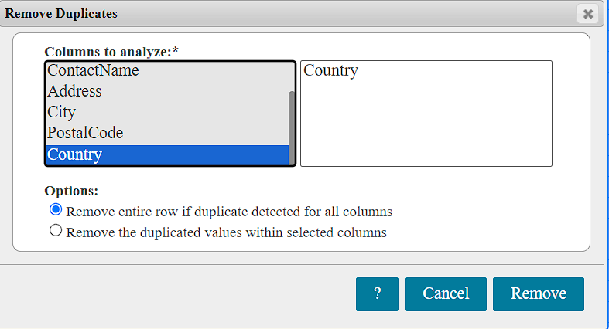

Count the rows for the number of distinct values in the column.

1. Click on Stat → Summary Stats → Columns
2. Select columns → Customer ID
3. Statistics → n
4. Click Compute!
5. Search for a particular country:
   1. Click on Edit -> Find and Replace or use Ctrl+F (Cmd+F for Mac)
   2. Find -> Enter the country to search for.
   3. Click Find